UNIVERSITY ADMIT ELIGIBILITY PREDICTOR ASSIGNMENT - 2

|  |  |
| --- | --- |
| Date | 26th September 2022 |
| Team ID | PNT2022TMID54388 |
| Student Name | P.K.Raghul (310619106106) |
| Domain Name | Education |
| Project Name | University Admit Eligibility Predictor |
| Maximum Marks | 2 Marks |

# 1.)IMPORT THE REQUIRED LIBRARIES

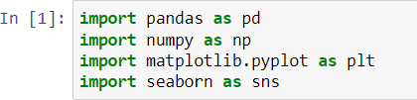

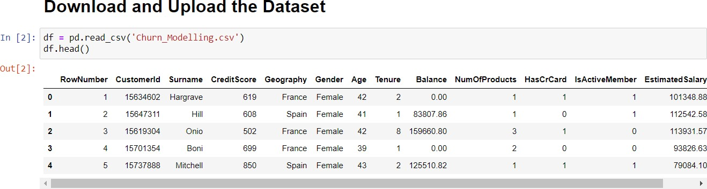**2.)DOWNLOAD AND UPLOAD THE DATASET**

**3.)HANDLE MISSING VALUES IN THE DATASET**

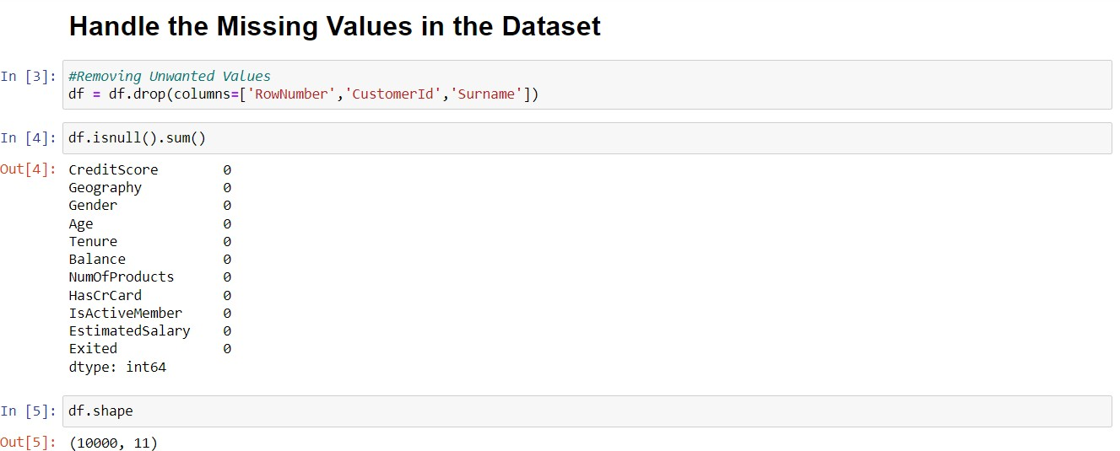

**4.) PERFORM THE DESCRIPTIVE STATISTICS ON THE DATASET**

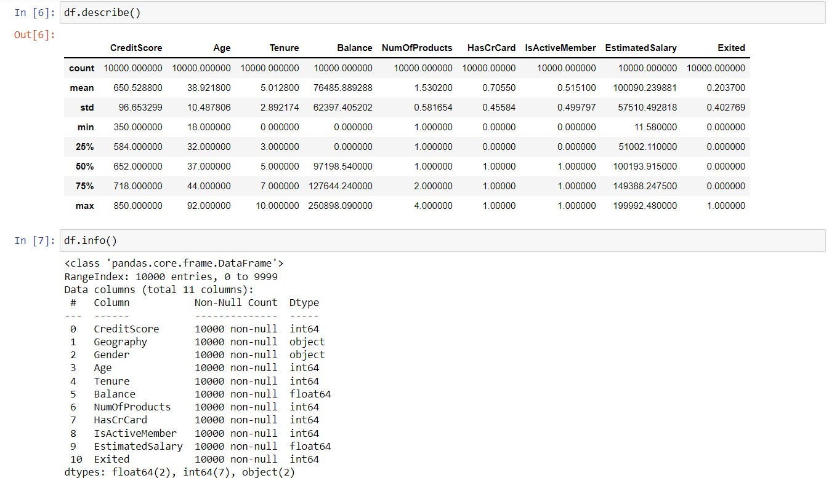

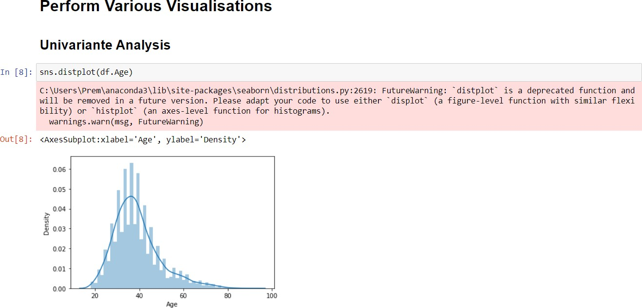**5.) PERFORM VARIOUS VISUALISATIONS a.) UNIVARIANTE ANALYSIS**

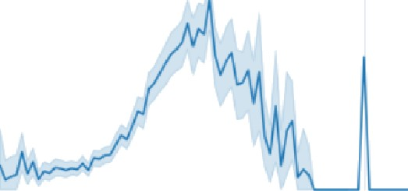

In sns.lineplot(df.Age,df.Exited)

C:\users\Prem\anaconda3\lib\site- packages\seabOru\_d ecOrators.Dy:36: FutureWarniug: Pass the *OllOwi"8 variables as keywOrd arg s: x, y. From version 0.12, the only valid positional argument will be ’data’, aud passing other arguments without an explicit keyword will result in an error or misinterpretation.

0.J[9] <AxesSubp1ot:x1abel='Age', ylabel= Exited'›

00

20

30

40

TO

60

70

RO

9

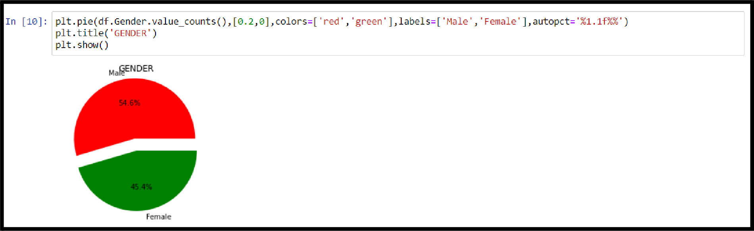

n [ ] : sn s . be cplot(df . NumofP rod u ct s . va Inc con nts ( ) . index, df . tlumO*Prod net s . va1 ue con nt s ( ) )

c:\Users\Prem\anaconda3\lib\site oaclages\seaborn\ decorators.py:36: FutureNarning: Pass the *ollowing variables as keyword arg

s : x, y . *F row ver z I on a .* 12, I he o nly val id pos it i ona I argument will be dad a‘ , a nd oa s si ng *of âer* a rgument s i9i th out an expl i c it ma rnings . warn (

<AxesSubolot:ylabel='Num0*Produ<ts'›

lO0O

# b.) BI - VARIANTE ANALYSIS

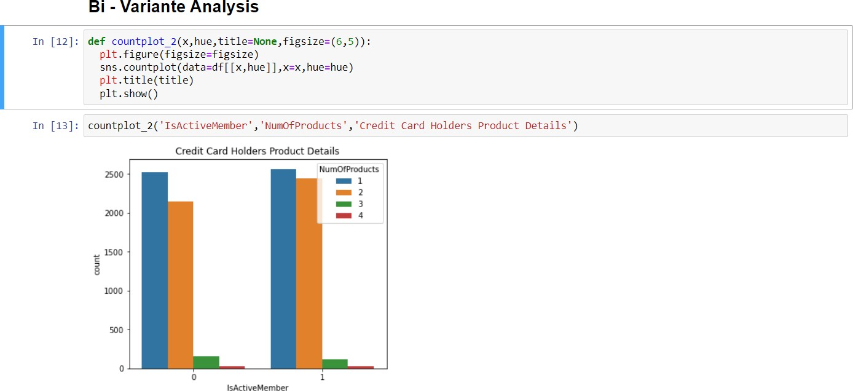

**c.) MULTI - VARIANTE ANALYSIS**

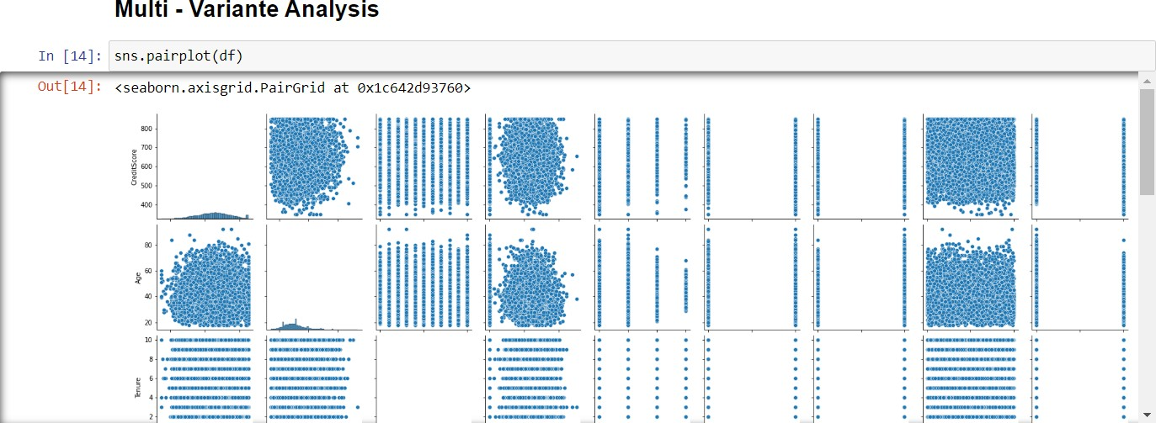

  

In [ 1sj : df. com( )

! ''

Ba!ance   !WiveM em be r

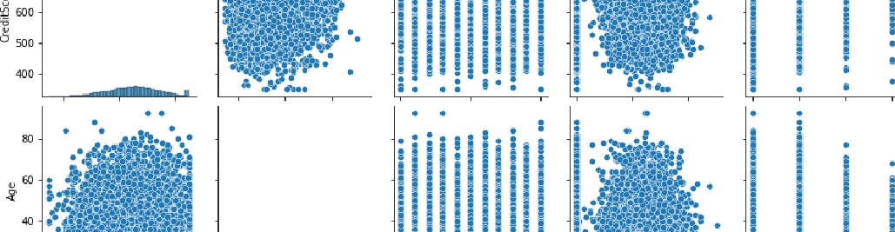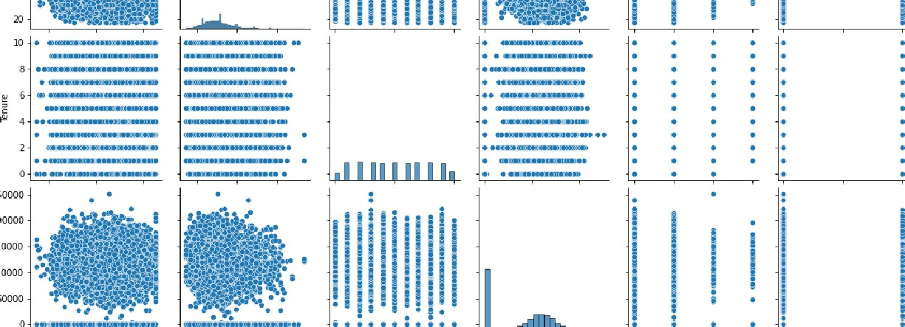

1

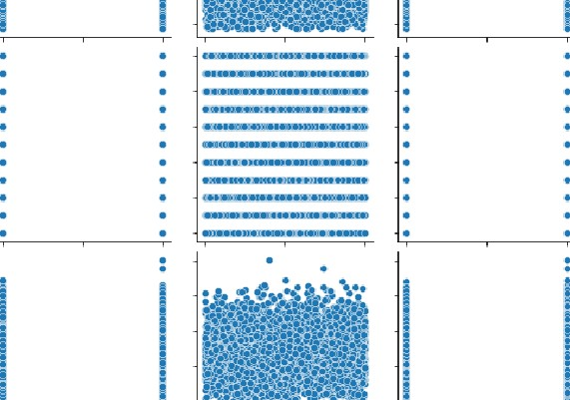



E xi fed

|  |  |  |  |  |  |  |  |  |
| --- | --- | --- | --- | --- | --- | --- | --- | --- |
|  | **AQe** | **Teuwe** | **Baauce** | **Num‹MProduca** | **HasCrCard** | **lsAcivvMember** | **EsimaMdBaag** | **Exed** |
| Credit6core | 1.000000 -0.0089b5 | 0.00D842 | 0.006268 | 0.012238 | fi 00S45B | 0.025654 | 0.00fi 384 | -0.027094 |
| Age | -0.003966 4 .0000D0 | -0.00999Z | 0.028308 | -0.030680 | -0.0fi 4 724 | 0.085472 | -0.00720fi | 0.285323 |
| Tenure | 0.000842 -0.009fi9J | fi.00D000 | -0.04 2254 | 0.013^44 | 0.022583 | -0.02B362 | 0.007Z84 | -0.0 4 40D4 |
| Balance | 0 006268 0 02B3D8 | -O 04 2Z54 | 4 000000 | -0 304fi BO | -0 04 485B | -O D084 | 0 012Z97 | 4 B538 |
| NuMGfProHHets | 0 012288 —0 0306B0 | 0 04 344H | —0 304fi 80 | 1 000000 | 0 83 | 0 0098fi 2 | 0 01^204 | —0 0HT820 |
| HasCrCaN | —0 005458 0 OU 721 | 0 022583 | —0 04 4858 | 0 O03fi 88 | fi OOOOOD | —0 0fi 4 866 | 0 009983 | —0 38 |



**Esti** m ated Salary —0 00fi —0 0072D1 0 00778H 0 0 2797 0 01420A —0 009933 —0 0fi 4 424 1 OOOOOO 0 0 4 2097



# 6.) FIND AND REPLACE THE OUTLIERS

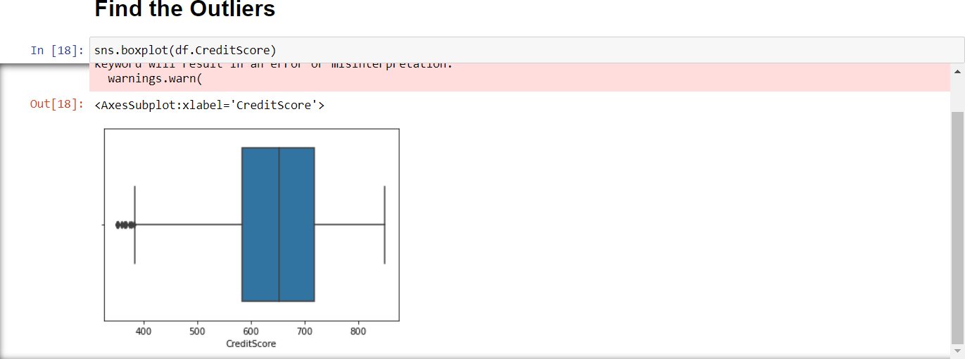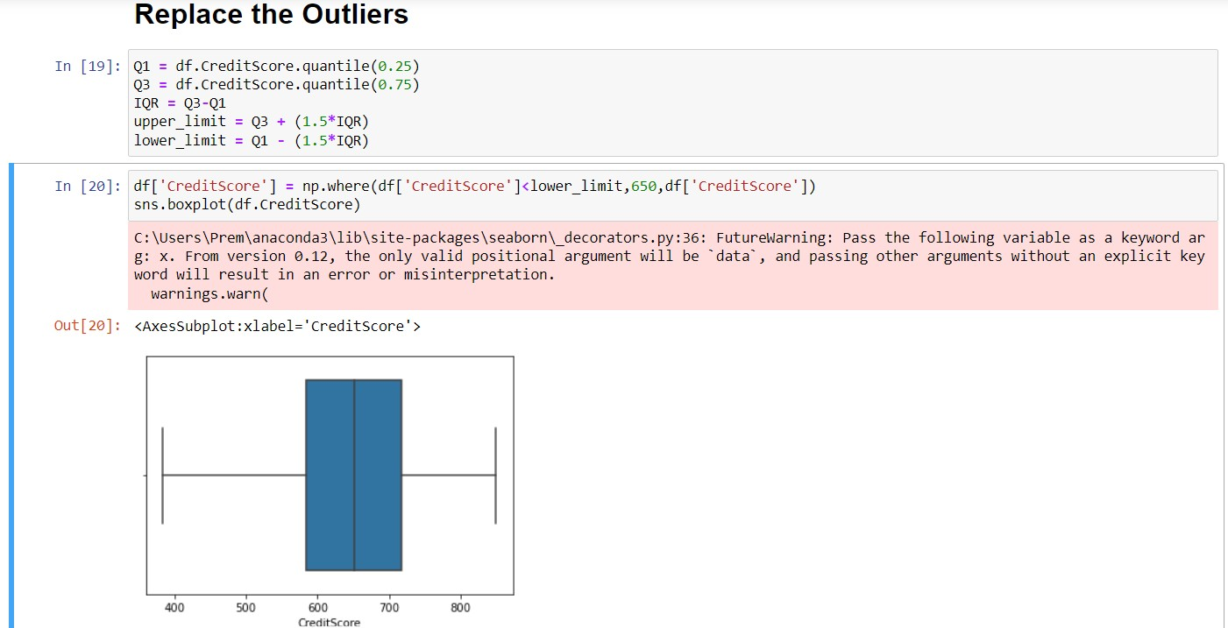

**7.) CHECK FOR CATEGORICAL COLUMNS AND ENCODE THEM**

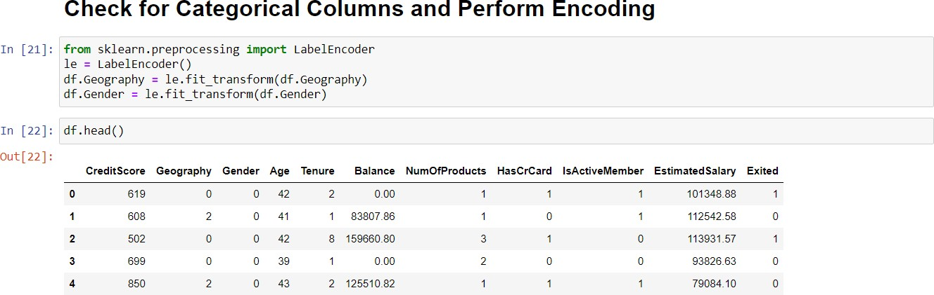

**8.)SPLIT DATA INTO DEPENDENT AND INDEPENDENT VARIABLES**

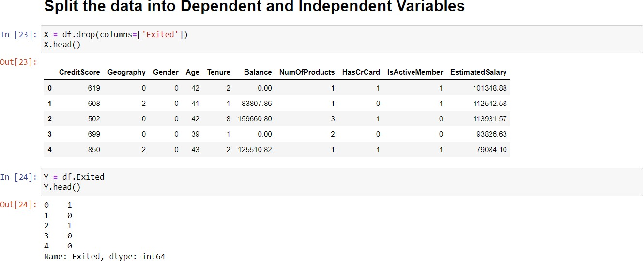

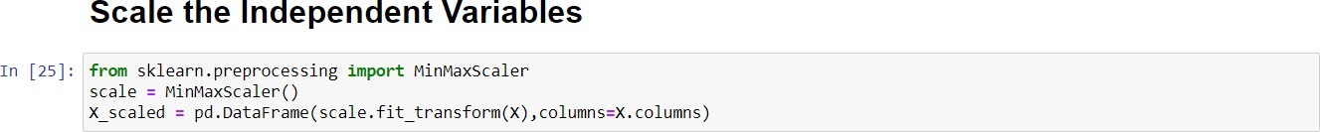**9.) SCALE THE INDEPENDENT VARIABLES**

**10.)SPLIT THE DATA INTO TRAINING AND TESTING**

